1. DATA ARCHITECTURE IMPROVEMENTS
Current Gap → Recommended Enhancement
Current: Basic S3 folders (raw/inventory, raw/shipments, raw/demand)
Recommended: Medallion Architecture
S3 Structure:
├── bronze/ # Raw ingestion (ERP, WMS, TMS feeds)
├── silver/ # Cleaned, validated, standardized data
├── gold/ # Business-ready aggregated metrics
└── athena-results/
Why this matters for you:
- Your Excel experience means you know dirty data firsthand
- Bronze→Silver layer catches data quality issues before they corrupt forecasts
- Prevents the "garbage in, garbage out" problem that affects Holt-Winters accuracy

2. FORECASTING MODEL IMPROVEMENTS
Current Limitation in the SOP
The SOP uses only Multiplicative Holt-Winters, which has weaknesses:
# CURRENT: Single model approach
model = ExponentialSmoothing(
demand_series, trend='add',
seasonal='mul'
).fit()
Recommended: Model Competition Framework
import boto3
from statsmodels.tsa.holtwinters import ExponentialSmoothing
from statsmodels.tsa.statespace.sarimax import SARIMAX
import numpy as np
import pandas as pd

def model_competition(demand_series, seasonal_periods=12):
"""
Run multiple models and select best by MAPE
Practical for supply chain professionals who need reliability
"""
results = {}

# Model 1: Multiplicative Holt-Winters (current SOP)
try:
hw_mul = ExponentialSmoothing(
demand_series,
trend='add',
seasonal='mul',
seasonal_periods=seasonal_periods
).fit()
hw_mul_mape = calculate_mape(
demand_series.values,
hw_mul.fittedvalues.values
)
results['HW_Multiplicative'] = {
'model': hw_mul,
'mape': hw_mul_mape,
'forecast': hw_mul.forecast(3)
}
except Exception as e:
print(f"HW Multiplicative failed: {e}")

# Model 2: Additive Holt-Winters
# Better when seasonality doesn't scale with level
try:
hw_add = ExponentialSmoothing(
demand_series,
trend='add',
seasonal='add',
seasonal_periods=seasonal_periods
).fit()
hw_add_mape = calculate_mape(
demand_series.values,
hw_add.fittedvalues.values
)
results['HW_Additive'] = {
'model': hw_add,
'mape': hw_add_mape,
'forecast': hw_add.forecast(3)
}
except Exception as e:
print(f"HW Additive failed: {e}")

# Model 3: Simple Moving Average baseline
# Always good to have a naive benchmark
window = seasonal_periods
sma_fitted = demand_series.rolling(window=window).mean()
valid_mask = ~sma_fitted.isna()
sma_mape = calculate_mape(
demand_series[valid_mask].values,
sma_fitted[valid_mask].values
)
results['SMA_Baseline'] = {
'model': None,
'mape': sma_mape,
'forecast': pd.Series([sma_fitted.iloc[-1]] * 3)
}

# Select best model
best_model_name = min(results, key=lambda x: results[x]['mape'])
best_result = results[best_model_name]

print(f"\nModel Competition Results:")
print("-" * 40)
for name, res in results.items():
marker = " ← SELECTED" if name == best_model_name else ""
print(f"{name}: MAPE = {res['mape']:.2f}%{marker}")

return best_result, results

def calculate_mape(actuals, fitted):
"""Safe MAPE calculation avoiding division by zero"""
mask = actuals != 0
return float(np.mean(
np.abs((actuals[mask] - fitted[mask]) / actuals[mask])
) * 100)

# Usage
demand_hist = pd.Series([
100, 115, 125, 140, 160, 180,
175, 190, 210, 230, 220, 250
] * 2)

best_model, all_results = model_competition(demand_hist)

3. ABC-XYZ SEGMENTATION LAYER
This is a major gap in the current SOP — critical for any supply chain professional
def abc_xyz_classification(inventory_df):
"""
ABC: Classify by revenue/value contribution
XYZ: Classify by demand variability (CV = std/mean)

This determines which items need:
- Complex forecasting (AX = high value, stable demand)
- Simple reorder points (CZ = low value, erratic demand)
- Most attention from you as SC professional
"""

# ABC Classification
inventory_df = inventory_df.sort_values(
'annual_revenue', ascending=False
)
inventory_df['cumulative_pct'] = (
inventory_df['annual_revenue'].cumsum() /
inventory_df['annual_revenue'].sum() * 100
)

def abc_label(cum_pct):
if cum_pct <= 80:
return 'A' # Top 80% revenue = ~20% SKUs
elif cum_pct <= 95:
return 'B' # Next 15% revenue
else:
return 'C' # Bottom 5% revenue = ~50% SKUs

inventory_df['ABC'] = inventory_df['cumulative_pct'].apply(abc_label)

# XYZ Classification using Coefficient of Variation
inventory_df['CV'] = (
inventory_df['demand_std'] / inventory_df['demand_mean']
)

def xyz_label(cv):
if cv <= 0.5:
return 'X' # Stable demand - best for Holt-Winters
elif cv <= 1.0:
return 'Y' # Moderate variability
else:
return 'Z' # Highly erratic - consider different model

inventory_df['XYZ'] = inventory_df['CV'].apply(xyz_label)
inventory_df['Segment'] = inventory_df['ABC'] + inventory_df['XYZ']

# Recommended action per segment
action_map = {
'AX': 'Holt-Winters + Tight Safety Stock Monitoring',
'AY': 'Holt-Winters + Higher Safety Stock Buffer',
'AZ': 'Newsvendor Model + Manual Review Required',
'BX': 'Simple Exponential Smoothing',
'BY': 'Exponential Smoothing + Safety Stock',
'BZ': 'Reorder Point with High Safety Stock',
'CX': 'Min/Max Policy',
'CY': 'Min/Max with Buffer',
'CZ': 'Consider Discontinuation or VMI'
}

inventory_df['Recommended_Action'] = (
inventory_df['Segment'].map(action_map)
)

return inventory_df

# Example usage
sample_data = pd.DataFrame({
'SKU': [f'SKU_{i:03d}' for i in range(1, 11)],
'annual_revenue': [
50000, 45000, 30000, 25000, 15000,
8000, 5000, 3000, 1500, 500
],
'demand_mean': [500, 450, 300, 250, 150, 80, 50, 30, 15, 5],
'demand_std': [50, 135, 90, 200, 120, 72, 50, 45, 22, 8]
})

classified = abc_xyz_classification(sample_data)
print(classified[['SKU', 'ABC', 'XYZ', 'Segment', 'Recommended_Action']])

4. ENHANCED INVENTORY HEALTH SCORECARD
Translating your Excel metrics to AWS — familiar KPIs, automated delivery
def inventory_health_scorecard(inventory_df, forecast_results):
"""
Replicates your Excel inventory health analysis
but automated, scalable, and real-time on AWS

Key metrics supply chain professionals track:
- Days of Supply (DOS)
- Inventory Turnover
- Stockout Rate
- Excess Inventory Value
- Dead Stock Identification
"""

scorecard = inventory_df.copy()

# Days of Supply
scorecard['DOS'] = (
scorecard['current_stock'] /
scorecard['avg_daily_demand']
)

# Inventory Turnover (annualized)
scorecard['Turnover'] = (
scorecard['annual_demand'] /
scorecard['avg_inventory']
)

# Stockout Risk Flag
scorecard['Stockout_Risk'] = (
scorecard['current_stock'] < scorecard['ROP']
)

# Excess Inventory (stock beyond max coverage)
max_coverage_days = 90 # Configurable per your policy
scorecard['Max_Stock'] = (
scorecard['avg_daily_demand'] * max_coverage_days
)
scorecard['Excess_Units'] = (
scorecard['current_stock'] - scorecard['Max_Stock']
).clip(lower=0)
scorecard['Excess_Value'] = (
scorecard['Excess_Units'] * scorecard['unit_cost']
)

# Dead Stock (no movement in 90+ days)
scorecard['Dead_Stock_Flag'] = (
scorecard['days_since_last_movement'] > 90
)

# Health Score (0-100)
def health_score(row):
score = 100
if row['Stockout_Risk']:
score -= 30
if row['DOS'] > max_coverage_days:
score -= 20
if row['Dead_Stock_Flag']:
score -= 25
if row['Turnover'] < 4:
score -= 15
if row['MAPE'] > 20:
score -= 10
return max(0, score)

scorecard['Health_Score'] = scorecard.apply(health_score, axis=1)

# Health Band
scorecard['Health_Band'] = pd.cut(
scorecard['Health_Score'],
bins=[0, 40, 70, 100],
labels=['Critical', 'Warning', 'Healthy']
)

return scorecard

5. REAL-TIME DATA PIPELINE (AWS Glue + EventBridge)
Current SOP Gap: Manual data uploads. Recommended: Automated streaming
RECOMMENDED DATA FLOW ARCHITECTURE:

ERP/WMS System
↓
AWS Transfer Family (SFTP) or API Gateway
↓
S3 Bronze Layer (raw data lands here)
↓
AWS Glue (ETL - data cleaning & transformation)
↓
S3 Silver Layer (clean, validated data)
↓
Amazon EventBridge (triggers on new data arrival)
↓
Lambda → SageMaker (runs Holt-Winters + Newsvendor)
↓
S3 Gold Layer (results stored)
↓
QuickSight Dashboard (auto-refreshes)
+
SNS Alerts (exception notifications)
EventBridge Rule Example (JSON config):
{
"source": ["aws.s3"],
"detail-type": ["Object Created"],
"detail": {
"bucket": {
"name": ["supply-chain-control-tower-yourname"]
},
"object": {
"key": [{"prefix": "silver/demand/"}]
}
}
}

6. ENHANCED ALERTING FRAMEWORK
Current SOP: Only 2 alerts (MAPE > 15%, stock < ROP)
Recommended: Tiered Alert Matrix
def enhanced_alert_engine(metrics_dict, sku_data):
"""
Multi-tier alerting beyond the basic SOP
Mirrors the exception reporting you'd do in Excel
but automated
"""
import boto3
import json

sns_client = boto3.client('sns', region_name='us-east-1')
SNS_TOPIC_ARN = 'arn:aws:sns:us-east-1:ACCOUNT:supply-chain-alerts'

alerts = []

for _, item in sku_data.iterrows():

# CRITICAL Alerts (Immediate Action Required)
if item['current_stock'] <= 0:
alerts.append({
'severity': 'CRITICAL',
'type': 'STOCKOUT',
'sku': item['SKU'],
'message': f"SKU {item['SKU']} is OUT OF STOCK",
'action': 'Place emergency order immediately'
})

if item['MAPE'] > 30:
alerts.append({
'severity': 'CRITICAL',
'type': 'FORECAST_ACCURACY',
'sku': item['SKU'],
'message': f"MAPE {item['MAPE']:.1f}% severely exceeds threshold",
'action': 'Manual forecast review required'
})

# WARNING Alerts (Action within 24-48 hours)
if 0 < item['current_stock'] < item['ROP']:
alerts.append({
'severity': 'WARNING',
'type': 'BELOW_ROP',
'sku': item['SKU'],
'message': f"Stock {item['current_stock']} below ROP {item['ROP']:.0f}",
'action': f"Initiate replenishment order of {item['EOQ']:.0f} units"
})

if 15 < item['MAPE'] <= 30:
alerts.append({
'severity': 'WARNING',
'type': 'FORECAST_ACCURACY',
'sku': item['SKU'],
'message': f"MAPE {item['MAPE']:.1f}% exceeds 15% threshold",
'action': 'Review demand pattern for anomalies'
})

# INFO Alerts (Monitor)
if item['Excess_Value'] > 10000:
alerts.append({
'severity': 'INFO',
'type': 'EXCESS_INVENTORY',
'sku': item['SKU'],
'message': f"Excess inventory value: ${item['Excess_Value']:,.0f}",
'action': 'Consider markdown or demand generation'
})

if item['DOS'] > 90:
alerts.append({
'severity': 'INFO',
'type': 'OVERSTOCK',
'sku': item['SKU'],
'message': f"Days of Supply: {item['DOS']:.0f} days",
'action': 'Review max stock policy'
})

# Send consolidated alert
if alerts:
critical_count = sum(1 for a in alerts if a['severity'] == 'CRITICAL')
warning_count = sum(1 for a in alerts if a['severity'] == 'WARNING')

subject = f"Supply Chain Alert: {critical_count} Critical, {warning_count} Warning"

message_body = f"""
SUPPLY CHAIN CONTROL TOWER - EXCEPTION REPORT
Generated: {pd.Timestamp.now().strftime('%Y-%m-%d %H:%M UTC')}
{'='*50}

SUMMARY: {critical_count} Critical | {warning_count} Warning | {len(alerts)-critical_count-warning_count} Info

ALERTS:
"""
for alert in sorted(alerts, key=lambda x:
['CRITICAL','WARNING','INFO'].index(x['severity'])):
message_body += f"""
[{alert['severity']}] {alert['type']} - SKU: {alert['sku']}
Issue: {alert['message']}
Action: {alert['action']}
"""

sns_client.publish(
TopicArn=SNS_TOPIC_ARN,
Subject=subject,
Message=message_body
)

return alerts

7. QUICKSIGHT DASHBOARD IMPROVEMENTS
Recommended Dashboard Pages Beyond Current SOP:
Page 1: EXECUTIVE SUMMARY
├── Overall Inventory Health Score (gauge chart)
├── OTIF % trend (line chart - 13 weeks)
├── Total Stockout Risk Value ($)
├── Excess Inventory Value ($)
└── Fill Rate by Product Category

Page 2: FORECAST ACCURACY MONITOR
├── MAPE by SKU (bar chart, color-coded by threshold)
├── MAD trend over time
├── Forecast vs Actual (last 12 periods)
└── Model accuracy by ABC segment

Page 3: INVENTORY POSITIONING
├── ABC-XYZ matrix (scatter plot)
├── DOS distribution (histogram)
├── ROP breach alerts (table)
└── Safety stock adequacy (% SKUs with sufficient SS)

Page 4: SUPPLIER PERFORMANCE
├── Lead time variability by supplier
├── On-time delivery rate
├── Quality rejection rate
└── OTIF by supplier

Page 5: DEMAND INTELLIGENCE
├── Holt-Winters forecast vs actuals
├── Seasonality index heatmap
├── Trend velocity by category
└── Demand volatility (CV) distribution

8. COST OPTIMIZATION & SECURITY IMPROVEMENTS
IAM Security Enhancement
Current SOP: AmazonSageMakerFullAccess (too broad)

Recommended: Least-privilege custom policy

{
"Version": "2012-10-17",
"Statement": [
{
"Effect": "Allow",
"Action": [
"sagemaker:CreateProcessingJob",
"sagemaker:DescribeProcessingJob",
"sagemaker:CreateNotebookInstance",
"sagemaker:StartNotebookInstance"
],
"Resource": "arn:aws:sagemaker:*:*:*supply-chain*"
},
{
"Effect": "Allow",
"Action": [
"s3:GetObject",
"s3:PutObject",
"s3:ListBucket"
],
"Resource": [
"arn:aws:s3:::supply-chain-control-tower-*",
"arn:aws:s3:::supply-chain-control-tower-*/*"
]
}
]
}
Cost Management
Estimated Monthly Costs (mid-scale deployment):
┌─────────────────────┬──────────────┬─────────────────────┐
│ Service │ Current SOP │ Recommended │
├─────────────────────┼──────────────┼─────────────────────┤
│ SageMaker │ Always-on │ Scheduled jobs only │
│ │ ~$150/mo │ ~$30/mo │
├─────────────────────┼──────────────┼─────────────────────┤
│ S3 │ No lifecycle │ 90-day archive rule │
│ │ ~$25/mo │ ~$10/mo │
├─────────────────────┼──────────────┼─────────────────────┤
│ Lambda │ Basic │ Optimized memory │
│ │ ~$5/mo │ ~$3/mo │
├─────────────────────┼──────────────┼─────────────────────┤
│ QuickSight │ Standard │ Standard │
│ │ ~$24/mo │ ~$24/mo │
└─────────────────────┴──────────────┴─────────────────────┘

SAVINGS: ~$107/month by using scheduled SageMaker jobs
instead of always-on notebook instances

9. IMPLEMENTATION PRIORITY ROADMAP
Recommended phased approach leveraging your existing SC expertise:
PHASE 1 (Weeks 1-4): Foundation — Quick Wins
├── ✅ Deploy current SOP as baseline
├── ✅ Add ABC-XYZ classification layer
├── ✅ Connect real data (replace sample series)
└── ✅ Set up 5-tier alerting

PHASE 2 (Weeks 5-8): Intelligence Layer
├── ✅ Add model competition framework
├── ✅ Build inventory health scorecard
├── ✅ Implement Glue ETL pipeline
└── ✅ Expand QuickSight to 5 dashboard pages

PHASE 3 (Weeks 9-12): Optimization
├── ✅ Multi-echelon if you have distribution centers
├── ✅ Supplier lead time integration
├── ✅ S3 lifecycle cost optimization
└── ✅ Least-privilege IAM refinement

PHASE 4 (Ongoing): Advanced Capabilities
├── ✅ Amazon Forecast (AWS managed service)
│ - Handles holiday calendars automatically
│ - No model tuning required
├── ✅ Supply chain risk scoring
└── ✅ Automated purchase order generation

10. QUICK WINS FROM YOUR EXCEL EXPERIENCE
Specific Excel analyses to migrate first (highest ROI):
Excel Analysis | AWS Equivalent | Benefit
Manual VLOOKUP for SKU data | Athena SQL joins | Real-time, no errors
Pivot table inventory aging | QuickSight calculated fields | Auto-refreshed
Manual safety stock formula | Newsvendor Lambda | Runs on every data update
Color-coded ROP breach sheet | QuickSight alerts + SNS | Push notification to phone
Monthly MAPE tracking | CloudWatch metrics | Continuous monitoring
Ad-hoc excess stock reports | Scheduled Athena query | Daily automated delivery

Summary of Top 5 Highest-Impact Improvements
- Add ABC-XYZ segmentation — Ensures Holt-Winters is applied only where it adds value; prevents over-engineering low-value SKUs
- Implement model competition — Single model risk is real; automatic best-model selection improves forecast accuracy
- Build automated data pipeline (Glue + EventBridge) — Eliminates the manual upload bottleneck that makes Excel feel faster
- Expand alerting to 5 tiers — Current 2-alert system misses excess inventory and dead stock which are equally costly
- Add inventory health scorecard — Translates your Excel KPIs (DOS, turnover, excess) into an automated, always-current dashboard

Comprehensive Summary of Your Enterprise Enhancements
1. Medallion Data Architecture (S3 Bucket Blueprint)
By replacing flat S3 folders with a Medallion Data Lake, raw ERP dumps are isolated and cleansed before hitting predictive algorithms:
- Bronze Layer (s3://.../bronze/): Ingests raw, unvalidated CSV/JSON feeds directly from SAP, WMS, and TMS systems.
- Silver Layer (s3://.../silver/): AWS Glue ETL jobs clean, validate, cast datatypes, and convert records into optimized Apache Parquet format (partitioned by date).
- Gold Layer (s3://.../gold/): Contains business-ready, aggregated metrics (ABC-XYZ classifications, dynamic ROP values, health scores) ready for Athena queries and QuickSight dashboards.
2. Model Competition Framework
To avoid relying on a single model, the SageMaker pipeline runs candidate models simultaneously per SKU and automatically selects the one that minimizes MAPE %:
$$\text{Selected Model}=\arg{\min_{m∈\left\{\text{HW_Mul},\text{HW_Add},\text{SMA}\right\}}{{\text{MAPE}}_{m}}}$$
- Multiplicative Holt-Winters: Applied when seasonal variance scales with baseline growth.
- Additive Holt-Winters: Applied when seasonal variance remains constant regardless of level changes.
- Simple Moving Average (SMA Baseline): Serves as a naive benchmark for erratic or low-volume series.
3. ABC-XYZ Portfolio Segmentation Engine
Items are classified across a $3×3$ matrix to dictate forecasting complexity and inventory strategy:
- ABC Stratification (Revenue Contribution):
  - Class A: Top $80\%$ cumulative revenue (~$20\%$ SKUs) $→$ Strict daily monitoring + tight safety stock.
  - Class B: Next $15\%$ cumulative revenue (~$30\%$ SKUs) $→$ Standard automated replenishment.
  - Class C: Bottom $5\%$ cumulative revenue (~$50\%$ SKUs) $→$ Min/Max policy or VMI.
- XYZ Stratification (Demand Volatility via Coefficient of Variation $CV$):
$$CV=\frac{σ_{D}}{μ_{D}}$$
  - Class X ($CV≤0.5$): Stable demand $→$ Ideal for Holt-Winters.
  - Class Y ($0.5<CV≤1.0$): Moderate volatility $→$ Holt-Winters + higher buffer.
  - Class Z ($CV>1.0$): Erratic demand $→$ Newsvendor stochastic safety stock + manual exception review.
4. Automated Inventory Health Scorecard
Translates spreadsheet tracking into a 0–100 automated health score for every SKU:
- Base Score: 100 Points.
- Deductions:
  - Stockout Risk ($CurrentStock<ROP$): $-30$ points.
  - Overstock Risk ($DOS>90$ days): $-20$ points.
  - Dead Stock ($DaysSinceLastMovement>90$): $-25$ points.
  - Low Inventory Turnover ($Turnover<4$): $-15$ points.
  - Poor Forecast Accuracy ($MAPE>20\%$): $-10$ points.
- Health Bands: Healthy ($71\text{--}100$), Warning ($41\text{--}70$), and Critical ($0\text{--}40$).
5. Multi-Tiered Alerting Engine (AWS Lambda + SNS)
Replaces simple alerts with a 3-severity exception matrix:
- CRITICAL (Immediate Action): Stockout ($CurrentStock=0$) or severe forecast failure ($MAPE>30\%$).
- WARNING (24–48 Hour Action): Stock below dynamic ROP ($CurrentStock<ROP$) or elevated forecast error ($15\%<MAPE≤30\%$).
- INFO (Monitoring): Excess inventory value ($ExcessValue>\$10,000$) or overstock position ($DOS>90$ days).
6. 5-Page QuickSight Dashboard Layout
- Page 1: Executive Summary: Overall Inventory Health Score gauge, 13-week OTIF % trend, stockout risk value ($),andexcessinventoryvalue($).
- Page 2: Forecast Accuracy Monitor: MAPE % by SKU bar chart (color-coded), MAD/MSD trends over time, and accuracy by ABC segment.
- Page 3: Inventory Positioning: Interactive $3×3$ ABC-XYZ matrix scatter plot, DOS distribution histogram, and ROP breach tables.
- Page 4: Supplier Performance: Lead time variability by carrier, on-time delivery rates, and vendor OTIF metrics.
- Page 5: Demand Intelligence: Model competition forecast vs. actuals, seasonality index heatmaps, and demand volatility distribution.
7. FinOps & IAM Security Enhancements
- Least-Privilege Policy: Replaced AmazonSageMakerFullAccess with custom JSON policies restricting execution strictly to bucket paths matching supply-chain-control-tower-*.
- Cost Optimization: Shifted from always-on $24/7$ notebook instances to scheduled SageMaker Processing Jobs, saving ~$107/month.
Step-by-Step Execution Plan
[Phase 1: Security & Identity]
└── Create IAM Role `ControlTowerLeastPrivilegeRole` with inline S3/SNS policies.

[Phase 2: Medallion S3 Data Lake]
└── Create bucket `supply-chain-control-tower-[your-name]` with folders:
├── bronze/
├── silver/demand/
├── silver/shipments/
├── gold/analytics/
└── athena-results/

[Phase 3: Athena SQL External Tables]
└── Register `silver_shipments` and `gold_inventory_health` tables.

[Phase 4: SageMaker Intelligence Engine]
└── Execute Python script for Model Competition, ABC-XYZ, & Health Scorecard.

[Phase 5: Multi-Tier Lambda Alerting]
└── Deploy Python Lambda handler connected to SNS topic `supply-chain-alerts`.

[Phase 6: QuickSight Visual Suite]
└── Publish 5-page dashboard connected to Athena Gold Parquet tables.
Would you like to draft the AWS CDK or CloudFormation template to deploy this medallion data lake and IAM role automatically?

Process
Athena DDL Statements
Once you upload the generated .parquet files to your S3 bucket (s3://your-control-tower-bucket/raw/), run these DDL statements in the Athena Query Editor to register the tables:
Shipments Table (sap_shipments)

Shipments Table (sap_shipments)
SQL
CREATE EXTERNAL TABLE IF NOT EXISTS supply_chain_db.sap_shipments (
delivery_id STRING,
material_id STRING,
plant STRING,
carrier_id STRING,
quantity INT,
planned_lead_time_days INT,
actual_lead_time_days INT,
delay_days INT,
is_delayed INT,
shipment_date STRING
)
STORED AS PARQUET
LOCATION 's3://your-control-tower-bucket/raw/shipments/';
Inventory Table (sap_inventory)
SQL
CREATE EXTERNAL TABLE IF NOT EXISTS supply_chain_db.sap_inventory (
material_id STRING,
plant STRING,
current_stock INT,
safety_stock INT,
avg_daily_demand INT,
days_of_supply DOUBLE,
reorder_flag INT,
last_updated STRING
)
STORED AS PARQUET
LOCATION 's3://your-control-tower-bucket/raw/inventory/';

Multiplicative
Formula
The multiplicative model is:
- L_{t} = α (Y_{t} / S_{t–p} ) + (1 – α) [L_{t–1} + T_{t–1} ]
- T_{t} = γ [L_{t} – L_{t–1} ] + (1 – γ) T_{t–1}
- S_{t} = δ (Y_{t} / L_{t} ) + (1 – δ) S_{t–p}
- = (L_{t–1} + T_{t–1} ) S_{t–p}
Notation
Term | Description
L_{t} | level at time t, α is the weight for the level
T_{t} | trend at time t,
γ | weight for the trend
S_{t} | seasonal component at time t
δ | weight for the seasonal component
p | seasonal period
Y_{t} | data value at time t
 | fitted value, or one-period-ahead forecast, at time t
Method for calculating initial values for level and trend for multiplicative models
The following method assumes a seasonal length greater than 4.
- Find the mean, minimum, and maximum of the data. For this example:
  - Mean = 554.208
  - Min = 1
  - Max = 1498.47
- For each row of data, calculate:
- Let N equal the Seasonal length. For this example, N = 12.
- Run regression using the first N "temp values" (calculated in step 2) as the Y variable, and a vector of 1 through N as the X variable. So, for this example:
Y | X
4104.36 | 1
4104.36 | 2
4630.36 | 3
4922.80 | 4
4822.40 | 5
5601.83 | 6
4891.77 | 7
4604.44 | 8
4411.26 | 9
4123.66 | 10
4104.36 | 11
4104.36 | 12
- The slope of the regression line is the initial value for trend.
- Adjust the intercept for the regression line by subtracting:
The intercept for your data is 4705.24. Subtract 4103.36 from the intercept to obtain an adjusted intercept of 601.879. This adjusted intercept is the initial value for level.

The 2 Critical Rules to Keep Costs Near $0
To avoid unexpected charges while building and demonstrating this architecture:
- SageMaker Serverless Inference: Do not deploy a persistent real-time hosting instance (e.g., ml.m5.xlarge), which runs continuously at ~$150+/month if left on. Use SageMaker Serverless Inference or execute predictions directly within SageMaker Studio notebooks so you only pay for seconds of compute execution.
- QuickSight Subscription Management: Build your dashboards, capture video demos and screenshots for your portfolio/LinkedIn, and cancel or pause your QuickSight subscription before the 30-day Free Trial expires to prevent recurring $24/month user author fees.
Recommended Cost Safeguard
Set a hard budget alert in the AWS Console immediately:
- Search for AWS Budgets in the top search bar.
- Click Create budget $→$ Choose Zero spend budget or set a threshold of $5.00.
- Input your email address to receive immediate alerts if your forecasted monthly usage exceeds $5.00.
To ensure you do not incur a single dollar in charges after completing your portfolio project and when your free trial periods expire, follow this Teardown & Clean-Up Checklist.
Executing these steps once you have recorded your demo videos and captured screenshots will permanently stop all recurring billing meters in your AWS account.
Step-by-Step Clean-Up & Teardown Guide
1. Cancel your Amazon QuickSight Subscription (Most Critical)
QuickSight transitions to a paid monthly author subscription (~$24/month) after the 30-day trial ends unless canceled manually.
- Log into the AWS Console and search for QuickSight.
- Click on the user profile icon in the top right corner $→$ Select Manage QuickSight.
- In the left panel, click Account settings.
- Scroll to the bottom and click Delete account.
- Type delete to confirm and click Delete account. (This immediately stops any future subscription billing).
2. Delete SageMaker Serverless Endpoints & Studio Resources
- Search for SageMaker in the AWS top search bar.
- In the left panel, click Inference $→$ Endpoints.
- Select shipment-delay-classifier (or any endpoint created) $→$ Click Actions $→$ Delete.
- Click Endpoint configurations in the left panel $→$ Select configurations $→$ Click Actions $→$ Delete.
- Click Studio in the left panel $→$ Click Shut down all or delete any active user profiles/apps.
3. Empty and Delete your Amazon S3 Data Lake
S3 standard storage costs money once you exceed 5 GB or when the 12-month free tier ends.
- Search for S3 in the top search bar.
- Select your bucket supply-chain-control-tower-[your-name].
- Click Empty at the top $→$ Type permanently delete to confirm $→$ Click Empty.
- Once empty, return to the bucket list, select your bucket, and click Delete $→$ Type the bucket name to confirm.
4. Delete AWS Lambda Functions & SNS Topics
While Lambda and SNS are virtually free for low volumes, cleaning them up keeps your environment clear.
- Open AWS Lambda $→$ Select ControlTowerAlertHandler $→$ Click Actions $→$ Delete.
- Open Amazon SNS $→$ Click Topics $→$ Select ControlTowerAlerts $→$ Click Delete.
5. Delete IAM Execution Roles
- Open IAM $→$ Click Roles.
- Search for ControlTowerLambdaRole $→$ Select it and click Delete.
Zero-Dollar Safeguard: Set a $0.01 AWS Budget Alert
To guarantee you are never surprised by a hidden charge, set up a zero-spend budget right now:
- Search for AWS Budgets in the top search bar.
- Click Create budget.
- Select Zero spend budget (or set a hard threshold of $0.01).
- Enter your email address under Email recipients.
- Click Create budget.
If any background service or forgotten resource attempts to generate even 1 cent of billing, AWS will immediately email you an alert so you can log in and turn it off.

You will not lose your project work if you back up your code, documentation, and data assets before running the cleanup steps.
Because cloud resources like S3 buckets or SageMaker instances host live data and active compute environments, deleting them removes the active cloud hosting, but you can preserve 100% of your project code, datasets, analytics queries, and presentation assets locally for free.
Here is how to safely preserve your entire project for your portfolio before shutting down active AWS services:
What to Save Locally (Your Permanent Portfolio Assets)
- Code & Scripts: Save your Python scripts (e.g., generate_sap_data.py, your Holt-Winters & Newsvendor model script, and Lambda handlers) in a local folder or push them to a public GitHub repository.
- Datasets: Keep the local copies of your generated .csv and .parquet files (sap_inventory_mseg.parquet, sap_shipments_likp.parquet) on your hard drive or in your Git repository.
- SQL Queries & Schemas: Save your Athena CREATE TABLE and SQL KPI queries in .sql files or inside your project's GitHub README.md.
- Visuals & Demonstration Media:
  - Dashboard Screenshots: Capture high-resolution screenshots of your QuickSight control tower visuals (OTIF rate, Multiplicative trend charts, Heatmaps, and MAPE % cards).
  - Screen Recording: Record a short 2–3 minute video walking through your QuickSight dashboard, Athena queries, and demonstrating an automated SNS email alert firing.
  - Architecture Diagrams & SOP Documents: Keep the generated architecture diagram (.jpg) and your formal SOP (.pdf / .docx) in your project repository.
How Hiring Managers Evaluate Cloud Portfolio Projects
In professional supply chain analytics and data engineering, hiring managers do not inspect live running AWS infrastructure (which is costly and insecure to leave public). Instead, they look at your GitHub Repository and LinkedIn/Portfolio Write-up.
A complete, zero-cost portfolio presentation includes:
- GitHub Repository: Containing your raw code, SQL queries, synthetic datasets, and the step-by-step SOP documentation.
- Architecture Diagram: Showing how data flows from SAP $→$ S3 $→$ Athena/SageMaker $→$ QuickSight/Lambda.
- Project README / Video Walkthrough: Demonstrating your Multiplicative Holt-Winters forecasting results, Newsvendor safety stock/ROP calculations, and dashboard screenshots.
By capturing these media assets and saving your code files locally before running the cleanup checklist, your project remains permanently available to showcase on your resume and portfolio indefinitely—at $0 ongoing cost.

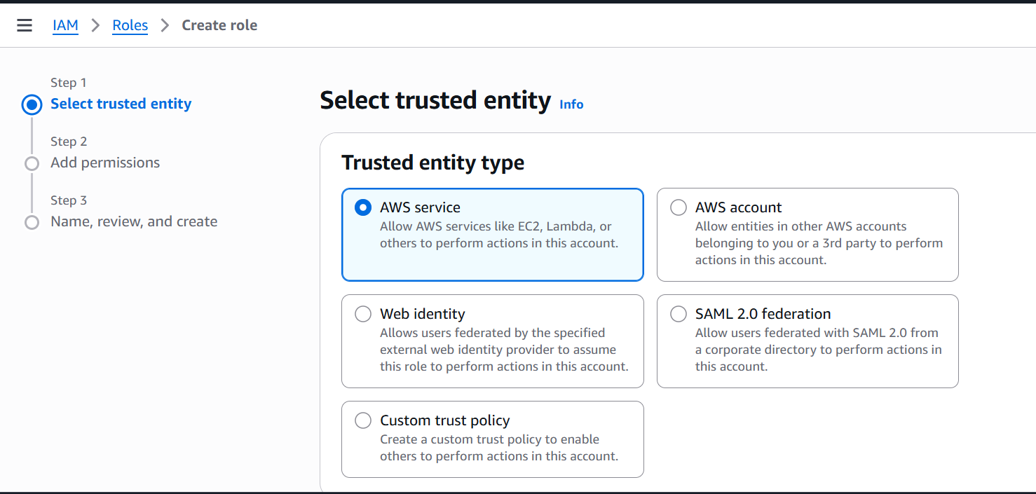

Choose AWS service (the option currently selected with the blue highlight).
Next Steps for This Page:
- Keep AWS service selected.
- Scroll down to the Use case section that appears below.
- Select Lambda as the service that will use this role.
- Click the blue Next button at the bottom right to move to Step 2: Add permissions.

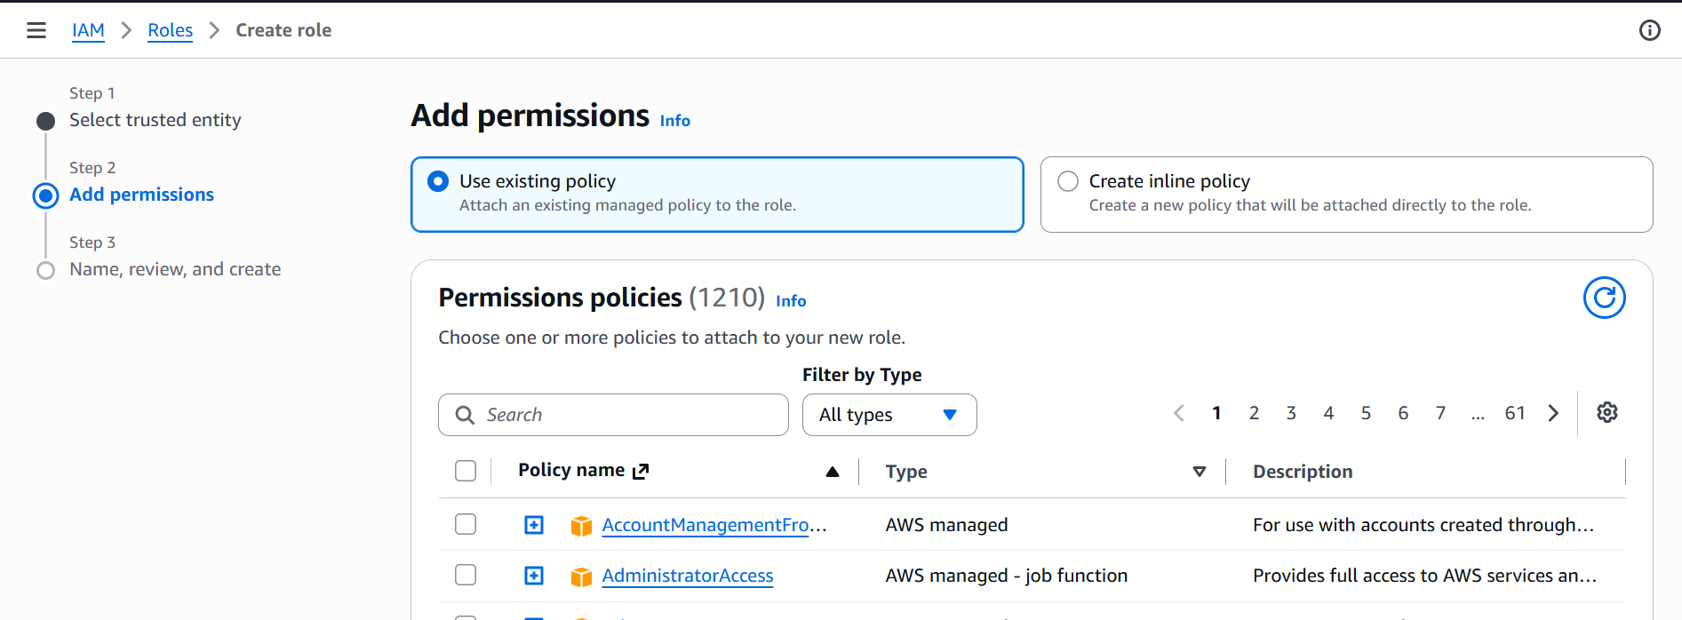
Keep Use existing policy selected (the blue highlighted option).
Next Steps on This Page:
Use the Search box under Permissions policies to find and check the boxes for each of these 4 policies one by one:
- Type AmazonS3ReadOnlyAccess in search $→$ Check the box next to it.
- Clear search, type AmazonSNSFullAccess $→$ Check the box next to it.
- Clear search, type AWSLambdaBasicExecutionRole $(AWS Managed)→$ Check the box next to it.
- Clear search, type AmazonSageMakerFullAccess $→$ Check the box next to it.
Once all 4 policies are checked, click the blue Next button at the bottom right to move to Step 3: Name, review, and create.

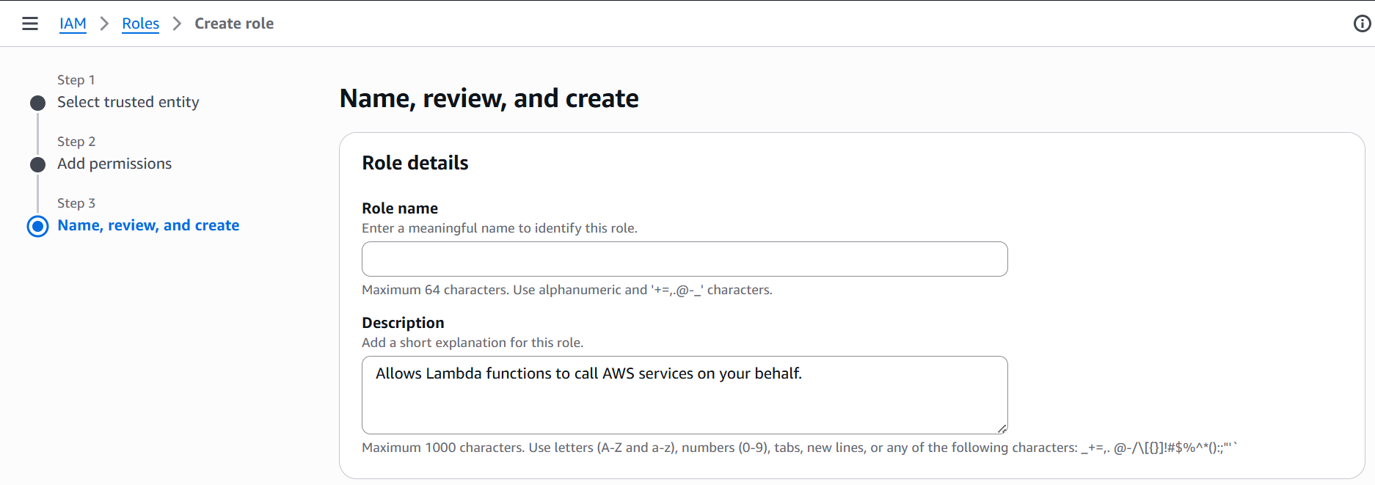
Enter ControlTowerLambdaRole in the Role name text box.
Next Steps:
- Leave the Description field as it is.
- Scroll all the way down to the bottom of the page.
- Verify that your permissions summary shows the policies you attached (AmazonS3ReadOnlyAccess, AmazonSNSFullAccess, AWSLambdaBasicExecutionRole, and AmazonSageMakerFullAccess).
- Click the blue Create role button at the bottom right
